TESS 80 - Claassen
September 2006
- Questionnaire -

Contact: Ryan Claassen <rclaasse@kent. edu>

- 500 Rs at 10 questions per R for a total of 5,000 RQs.

- Design involves within-subjects manipulations determined by Rs’ answers to a previous question. For each of three issues (abortion, defense spending and ideology), Rs are asked their own opinion, and then for their opinions of a first and second candidate generated by the computer according to a specified formula (shown below). For ideology, Rs are also asked about a third hypothetical candidate.

- Use graphics like the one in Sniderman and Tomz shown below in items #1, 4 and 7

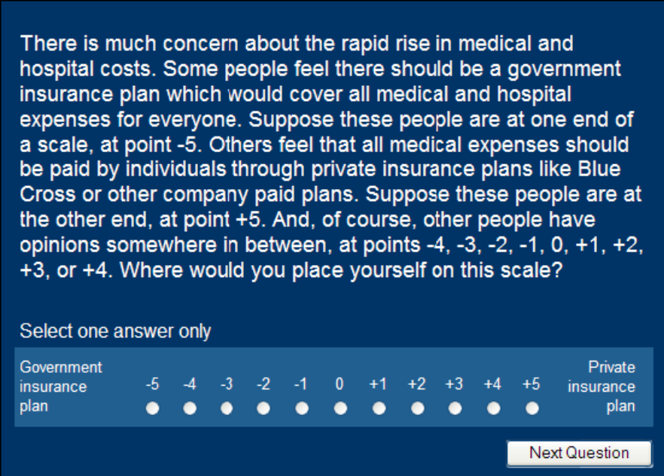

GENERATING CANDIDATES 1, 2 and 3:

Rs place themselves on an issue scale in items 1, 4 and 7. Using this self-placement, the computer will generate three different candidates:

Candidate 1: Candidate on the same side as the R (on the same side relative to the midpoint of the scale), but more extreme by 1 to 5 scale units, how much more extreme (1 to 5) will be determined at random.

The location of the FIRST candidate will be programmed as follows: Based on the R’s self-placement (X_{i}) the first candidate’s location (Z_{ei})will be on the same side of the scale but between 1 and 5 units farther out. The exact placement will be determined by the computer drawing an integer from the uniform distribution of integers between 1 and 5 (I_{i}) and using the following formula:

Z_{ei} = ((((X_{i}/|X_{i}|)*X_{i})+I_{i})* (X_{i}/|X_{i}|))

Under this formula, for example, an R self-placed at 3, when the randomly drawn integer is 3, will be assigned a First Candidate placed at 6.

Candidate 2: Candidate on the other side of each individual on the scale (the other side of the midpoint), but this hypothetical candidate will be one scale unit closer to the individual than the more extreme hypothetical candidate.

The location of the SECOND candidate (Z_{oi}) will be programmed as follows: Based on the R’s self-placement, the same random integer drawn for the First Candidate and the following formula will be used:

Z_{oi} = ((((X_{i}/|X_{i}|)*X_{i})-(I_{i}-1))* (X_{i}/|X_{i}|)).

In this case an R self-placed at 3, with a randomly drawn integer of 3, will have a Second Candidate placed at 1.

Candidate 3: Candidate on the same side of the midpoint, but even more extreme than the first more extreme candidate. How much more extreme will again be determined at random.

The location of the THIRD candidate (Z_{ei2}) is as follows: In addition to R’s self placement, as second integer, I_{i2} will be randomly drawn. The following formula will be used:
Since Z_{ei} has already been calculated as

Z_{ei} = ((((X_{i}/|X_{i}|)*X_{i})+I_{i})* (X_{i}/|X_{i}|))

Then Z_{ei2} would be calculated

Z_{ei2} = ((((X_{i}/|X_{i}|)*X_{i})+I_{i}+I_{i2})* (X_{i}/|X_{i}|))

For example, if R’s self-placement is at 3, the first integer is 3 and the second integer is 3, the Third Candidate would be placed at 9.

For those Rs who self-place as 0 (X_{i}=0), Z_{ei} will be determined by drawing an integer from the uniform distribution of integers from -5 to -1 and +1 to +5 (because of division in the forumula, 0 needs to be excluded from this draw) and Zei and Zoi would be computed thusly,

Ii is still an integer drawn from -5 to -1 and 1 to 5 with equal probability.

First candidate:
Zei = Ii+Xi

Second candidate:
Zoi = ((((Ii/|Ii|)*Ii)-1)+Xi)*((Ii/|Ii|)*-1)

Third candidate (Ii2 is an integer drawn from 1 to 5 with equal prob.
Ideology only):
Zei2=((((Ii/|Ii|)*Ii)+Ii2)+Xi)*(Ii/|Ii|)

[Abortion]

[Horizontal SP]
Q1. Pictured is a scale where -5 is very strong support for abortion, and +5 is very strong opposition of abortion. Where would you place yourself on this scale?

-5 | -4 | -3 | -2 | -1 | 0 | +1 | +2 | +3 | +4 | +5
Very strong support for abortion |  |  |  |  |  |  |  |  |  | Very strong opposition of abortion

Programming Note: Candidate locations generated here as outlined in the instructions above.

[Abortion Candidate Evaluations]

[SP]
Q2. You just placed yourself on a scale where -5 is very strong support for abortion and +5 is very strong opposition of abortion, but candidates sometimes cover an even broader range of positions. Using the broader candidate scale pictured (note, it ranges from -10 to +10), how would you evaluate a candidate who is located at [Zei – FIRST CANDIDATE LOCATION]?

[Show image/visual representation of -10 to +10 with candidate’s location on the scale]

Would you evaluate this candidate

Very unfavorably 1
Somewhat unfavorably 2
Neither favorably nor unfavorably 3
Somewhat favorably 4
Very favorably 5

[SP]
Q3. Again, on the broader scale for candidates pictured, how would you evaluate a candidate who is located at [Zoi – SECOND CANDIDATE LOCATION]?

[Show image/visual representation of -10 to +10 with candidate’s location on the scale]

Would you evaluate this candidate

Very unfavorably 1
Somewhat unfavorably 2
Neither favorably nor unfavorably 3
Somewhat favorably 4
Very favorably 5

[Defense Spending]

[SP]
Q4. One area the government allocates money for in each budget is the military. Some people feel the government spends too much on the military while others feel the government needs to spend more on the military. Pictured is a scale where -5 indicates you would support major decreases in military spending, and +5 indicates you would support major increases in military spending.

Where would you place yourself on this scale?

-5 | -4 | -3 | -2 | -1 | 0 | +1 | +2 | +3 | +4 | +5
Support major decreases in military spending |  |  |  |  |  |  |  |  |  | Support major increases in military spending

Programming Note: Candidate locations generated here as outlined in the instructions above.

[Defense Spending Candidate Evaluations]

[SP]
Q5. You just placed yourself on a scale where -5 indicates you would support major decreases in military spending, and +5 indicates you would support major increases in military spending, but candidates sometimes cover an even broader range of positions. Using the broader candidate scale pictured (note, it ranges from -10 to +10), how would you evaluate a candidate who is located at [Zei – FIRST CANDIDATE LOCATION]?

[Show image/visual representation of -10 to +10 with candidate’s location on the scale]

Would you evaluate this candidate

Very unfavorably 1
Somewhat unfavorably 2
Neither favorably nor unfavorably 3
Somewhat favorably 4
Very favorably 5

[SP]
Q6. Again, on the broader scale for candidates pictured, how would you evaluate a candidate who is located at [Zoi – SECOND CANDIDATE LOCATION]?

[Show image/visual representation of -10 to +10 with candidate’s location on the scale]

Would you evaluate this candidate

Very unfavorably 1
Somewhat unfavorably 2
Neither favorably nor unfavorably 3
Somewhat favorably 4
Very favorably 5

[Ideology]

[SP]
Q7. Pictured is a scale where -5 is very liberal, and +5 is very conservative. Where would you place yourself on this scale?

-5 | -4 | -3 | -2 | -1 | 0 | +1 | +2 | +3 | +4 | +5
Very liberal |  |  |  |  |  |  |  |  |  | Very conservative

Programming Note: Candidate locations generated here as outlined in the instructions above.

[Ideology Candidate Evaluations]

[SP]
Q8. You just placed yourself on a scale where -5 is very liberal and +5 is very conservative, but candidates sometimes cover an even broader range of positions. Using the broader candidate scale pictured (note, it ranges from -10 to +10), how would you evaluate a candidate who is located at [ZeI FIRST CANDIDATE LOCATION]?

[Show image/visual representation of -10 to +10 with candidate’s location on the scale]

Would you evaluate this candidate

Very unfavorably 1
Somewhat unfavorably 2
Neither favorably nor unfavorably 3
Somewhat favorably 4
Very favorably 5

[SP]
Q9. Again, on the broader scale for candidates pictured, how would you evaluate a candidate who is located at [Zoi – SECOND CANDIDATE LOCATION]?

[Show image/visual representation of -10 to +10 with candidate’s location on the scale]

Would you evaluate this candidate

Very unfavorably 1
Somewhat unfavorably 2
Neither favorably nor unfavorably 3
Somewhat favorably 4
Very favorably 5

[SP]
Q10. Again, on an even broader scale for candidates pictured, how would you evaluate a candidate who is located at [Zei2 – THIRD CANDIDATE LOCATION]?

[Show image/visual representation of -10 to +10 with candidate’s location on the scale]

Would you evaluate this candidate

Very unfavorably 1
Somewhat unfavorably 2
Neither favorably nor unfavorably 3
Somewhat favorably 4
Very favorably 5

Insert standard close.

ADDITIONAL COMMENTS FROM AUTHOR:

- Let’s go forward with a graphic showing candidate locations for the evaluation prompts, something that would be on the screen with the evaluation prompts (My next comment addresses scaling concerns.)
  - Let’s have a graphic accompanying each candidate evaluation prompt that runs from +/-10 instead of +/-5 but has the same labels (This will work for all but the third ideology evaluation)
  - Perhaps place labels at approximately +/-5 to suggest the new scale covers more extreme options
  - Include a marker at the computer generated candidate location and a label that says, “Candidate Here” if possible
  - For the third candidate in the ideology evaluation the scale would need to range from +/-15
Thank you for your comments about the scales. I recognize that having candidates outside the +/-5 interval is a bit unorthodox/confusing, but ultimately it is where the experiment really gains traction on distinguishing between the two models. Fortunately the analyses will depend on distance between Rs and hypothetical candidates rather than locations, per se. This bit of trickery is the only way I can devise to ensure each subject gets a [more extreme] candidate with distance determined at random. However, the questions raised about what the sliding scales mean are well taken, and I am happy to take another shot at improving this aspect of the experiment. Noting that even bounded scales are quite subjective and few would argue that nothing exists beyond the scale endpoints, the outward pointing arrows mean that no matter how extreme an R is, a more extreme human exists (this makes my scales more subjective and poses problems for interpersonal comparisons, but probably not for intrapersonal comparisons). Nevertheless, I want to do whatever I can to convey to the Rs that scales represent a continuum and that even if they believe themselves to be at the most extreme position they can imagine, there may be someone who has staked out an even more extreme position (one that the R simply hadn’t imagined). I have given some thought to how I might prepare Rs for the moving endpoints. Reviewers will still have concerns, but I think this will be better (and it will give me something to use addressing concerns).

Qualification Flag & Display
Write the logic to set QFLAG1 at the end of the questionnaire (to prevent errors due to changed answers). The first variable will only show in data, not on-screen. The second will only display on-screen during testing, never in data.
Delete all if a qualification flag is not wanted; no qualification flag is set by default.

[SP]
[Quantum Spec: card = 2; col = 14]
QFLAG1 DATA ONLY: Qualification Flag
[Adjust values as needed]
Qualified 1
Not Qualified 2
Clearly describe conditions for setting QFLAG using question numbers and response values
Example: QFLAG = Not Qualified: default value.
QFLAG = Qualified: if (S1 = Yes) OR (S1 = No AND S2 >= 5)

[disp]
[Filter: isSurveyQC()]
Include this at the end of the questionnaire if you want qualification status displayed during testing.
QFLAG2 Qualification Flag = Show qualification status set in QFLAG1

